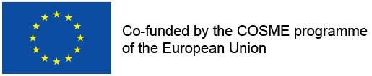
WP4 IMPLEMENTING ICBUILD JOINT INTERNATIONALIZATION STRATEGY
Task 4.1 ICBUILD FACT-FINDING MISSIONS in target markets
ICBUILD Mission to Sao Paulo, Brazil, FEICON fair, 1-9 April 2024
Travel vouchers for SMEs / Travel voucher application template
APPLICANT INFORMATION
Full name of the company
Industrial sector
Legal address
VAT registration number
Company website
Contact details of the representative attending the ICBUILD mission
Name Surname/ Email address/
Phone number
Brief description of the company and its main activity area(s) in regard to circular, green, and sustainable building and construction
Internationalization expectations
Motivation for applying for the ICBUILD Travel voucher for Brazil Mission
Brief description of the purpose for taking part in the ICBUILD Mission.
Brief description of company's expected outcomes from the ICBUILD mission
- I declare that ______________________________________(name of the applicant company) is a Small and medium-sized enterprise (SMEs) according to the EU recommendation 2003/361

- I confirm that have read and understood the “ICBUILD Travel vouchers for SMEs / Financial Agreement” and its requirements.

Name of the entity representative_______________________
Date, Place_______________
Signature____________________________

